BUILD A DASHBOARD TO TRACK SYSTEM PERFORMANCE METRICS SUCH AS CPU USAGE, RAM CONSUMPTION, AND LATENCY

Abstract / Project Summary
In the contemporary digital landscape, organizations across various industries are increasingly dependent on computing systems to perform critical operations, manage data, and deliver services efficiently. As businesses scale and adopt advanced technologies such as cloud computing, artificial intelligence, and big data analytics, the complexity of IT infrastructure continues to grow. This increased complexity brings with it the challenge of maintaining optimal system performance. Even minor inefficiencies in system operations can lead to significant disruptions, affecting productivity, user experience, and overall business outcomes. Therefore, continuous monitoring and analysis of system performance have become essential components of modern IT management.
This project, titled System Performance Monitoring Dashboard, aims to design and develop a comprehensive solution that enables real-time tracking and analysis of key system performance metrics. The primary objective of this project is to monitor critical indicators such as CPU utilization, memory consumption, disk input/output operations, and system latency. These metrics serve as fundamental indicators of system health and efficiency. By closely analyzing these parameters, it becomes possible to detect performance bottlenecks, identify abnormal patterns, and take corrective actions before issues escalate into major failures.
The project is based on a dataset collected over a period of thirty days, with observations recorded at hourly intervals. This structured dataset provides a detailed representation of system behavior under various conditions, including peak workload periods and idle times. By leveraging this data, the project performs in-depth analysis to uncover trends, correlations, and anomalies. The time-based nature of the dataset allows for the identification of recurring patterns, which are crucial for predictive analysis and capacity planning.
To achieve the objectives of the project, a combination of tools and technologies has been utilized. Microsoft Excel is used for initial data exploration and validation, providing a simple yet effective platform for identifying inconsistencies. SQL is employed for efficient data querying and aggregation, enabling the extraction of meaningful insights from large datasets. Python plays a significant role in data cleaning, transformation, and advanced analysis, utilizing libraries such as pandas and matplotlib for processing and visualization. Finally, Power BI is used to create an interactive and visually appealing dashboard that presents the analyzed data in an intuitive format.
The final outcome of this project is a dynamic dashboard that allows users to monitor system performance in real time. The dashboard provides visual representations of key metrics, making it easier to understand complex data and identify trends. By enabling proactive monitoring, the system helps reduce downtime, improve resource utilization, and enhance overall system efficiency. This project demonstrates the importance of integrating data analysis and visualization techniques in IT operations and highlights how such solutions can support informed decision-making and strategic planning.

Introduction
In today’s rapidly evolving technological environment, system performance monitoring has emerged as a critical requirement for organizations striving to maintain operational efficiency and deliver high-quality services. The increasing reliance on digital platforms for business operations, communication, and data management has made IT infrastructure the backbone of modern enterprises. As a result, ensuring the reliability, availability, and efficiency of these systems has become a top priority. System performance monitoring plays a vital role in achieving this objective by providing continuous insights into system behavior and enabling timely intervention when issues arise.
At the core of system performance monitoring are key metrics such as CPU utilization, memory usage, disk activity, and system latency. CPU utilization indicates how much processing power is being used at any given time, reflecting the workload on the system. Memory usage provides insights into how effectively the system manages its resources, particularly when running multiple applications simultaneously. Disk activity measures the rate of data read and write operations, which is crucial for understanding storage performance. Latency, on the other hand, represents the time taken for the system to respond to a request, directly impacting user experience. Together, these metrics provide a comprehensive view of system health and performance.
The importance of system monitoring has grown significantly with the advent of cloud computing and digital transformation. Modern IT environments are often distributed across multiple servers and locations, making it challenging to maintain consistent performance. Cloud-based systems, in particular, require continuous monitoring to ensure scalability, reliability, and cost efficiency. Monitoring tools help organizations track resource usage, identify inefficiencies, and optimize performance in real time.
Moreover, system performance monitoring is closely linked to business continuity and risk management. In industries such as banking, healthcare, and e-commerce, system failures can have serious consequences. For example, a delay in processing financial transactions can result in customer dissatisfaction and financial losses. In healthcare, system downtime can disrupt critical services and affect patient outcomes. In e-commerce, slow response times can lead to abandoned transactions and reduced revenue. These examples highlight the need for robust monitoring solutions that can ensure uninterrupted operations.
This project aims to address these challenges by developing a system performance monitoring dashboard that provides real-time insights into key metrics. By integrating data analysis and visualization techniques, the dashboard enables users to monitor system performance effectively and make informed decisions. The project not only demonstrates the practical application of data analytics in IT operations but also emphasizes the importance of proactive monitoring in maintaining system efficiency and reliability.

Problem Statement
Modern IT systems, despite their advanced capabilities, are often subject to various performance-related challenges that can significantly impact their efficiency and reliability. One of the most common issues faced by these systems is CPU overload, which occurs when the demand for processing power exceeds the available capacity. This situation can arise due to high user traffic, inefficient application design, or background processes consuming excessive resources. When CPU usage reaches critical levels, it leads to slower execution of tasks, increased response times, and overall degradation of system performance.
Another major challenge is memory saturation, which occurs when the system’s available memory is fully utilized. In such cases, the system may resort to using secondary storage, such as disk space, to compensate for the lack of memory. This process, known as paging or swapping, significantly slows down system performance and can lead to application crashes. Memory-related issues are particularly critical in systems that handle large volumes of data or run multiple applications simultaneously.
Latency is another key factor that affects system performance. High latency indicates delays in processing or communication, which can negatively impact user experience. In web-based applications, for example, increased latency can result in slow page loading times, causing frustration among users and potentially leading to loss of business. Latency issues can arise due to network congestion, inefficient data processing, or system overload.
The consequences of these performance issues are far-reaching. They can lead to reduced productivity, as users may struggle to complete tasks efficiently. In business environments, system downtime can result in financial losses and damage to reputation. Furthermore, poor system performance can hinder decision-making processes, particularly in organizations that rely on real-time data analysis.
Traditional methods of monitoring system performance often involve manual analysis of logs and reports, which is both time-consuming and prone to errors. These methods are not suitable for modern IT environments, where real-time monitoring is essential. There is a clear need for an automated solution that can provide continuous insights into system performance and enable proactive management.
This project addresses these challenges by developing a system performance monitoring dashboard that visualizes key metrics and provides real-time insights. The dashboard enables users to identify potential issues early and take corrective actions, thereby improving system efficiency and reliability.

Dataset Description
The dataset used in this project forms the backbone of the entire system performance analysis and dashboard development process. It consists of structured records capturing various system performance metrics over a continuous period of thirty days. The data is recorded at hourly intervals, ensuring a high level of granularity and enabling detailed time-series analysis. This temporal structure allows for the identification of patterns, trends, and anomalies that occur at different times of the day and across different days of the week.
One of the most critical components of the dataset is CPU utilization, which is categorized into multiple segments such as user CPU, system CPU, and I/O wait. User CPU represents the proportion of time spent executing user-level processes, which typically include applications and services running on the system. System CPU reflects the time spent on kernel-level operations, including system calls and background processes. I/O wait, on the other hand, indicates the time during which the CPU remains idle while waiting for input or output operations to complete. Analyzing these metrics collectively provides a comprehensive understanding of how processing resources are being utilized and helps in identifying performance bottlenecks.
Memory-related metrics are equally important in assessing system performance. The dataset includes information about total memory, used memory, and available memory. These metrics help in understanding how efficiently the system manages its memory resources. High memory utilization may indicate the presence of resource-intensive applications or potential memory leaks, while low available memory can lead to system instability and performance degradation. By analyzing memory usage patterns over time, it becomes possible to identify trends and optimize resource allocation.
In addition to CPU and memory metrics, the dataset also includes disk I/O statistics, which measure the rate of data read and write operations. Disk performance plays a crucial role in overall system efficiency, particularly in environments that handle large volumes of data. Slow disk operations can significantly impact application performance, leading to delays and reduced throughput. The dataset also captures load averages, which represent the average number of processes waiting for CPU execution over different time intervals. These values provide insights into system load and help predict future performance trends.
Latency is another key metric included in the dataset, representing the delay in system response time. High latency values may indicate network congestion, system overload, or inefficiencies in data processing. By analyzing latency in conjunction with other metrics, it is possible to identify the root causes of performance issues and implement appropriate solutions.
Overall, the dataset is comprehensive and well-structured, providing a solid foundation for detailed analysis and visualization. Its time-based nature and inclusion of multiple performance metrics make it highly suitable for developing an effective system performance monitoring dashboard.

Data Cleaning Process
Data cleaning is a fundamental step in the data analysis pipeline, as it ensures the accuracy, consistency, and reliability of the dataset before further processing. In this project, the data cleaning process involves several systematic steps aimed at preparing the dataset for meaningful analysis and visualization.
The first step in the cleaning process involves identifying and handling missing values. Missing data can occur due to various reasons, such as system errors, data collection failures, or interruptions during logging. These missing values can significantly affect the accuracy of analysis if not handled properly. Depending on the nature and extent of missing data, appropriate techniques such as imputation or removal are applied. For instance, missing values may be replaced with mean or median values, or in some cases, entire records may be removed if they do not contribute significantly to the analysis.
Another important aspect of data cleaning is the conversion of timestamps into a standardized datetime format. Since the dataset is time-based, accurate timestamp formatting is essential for performing time-series analysis. Once converted, additional features such as hour, day, and day of the week are extracted from the timestamp. These derived features play a crucial role in identifying temporal patterns and trends in system performance.
Outlier detection is also a critical component of the data cleaning process. Outliers are extreme values that deviate significantly from the normal range of data and may indicate anomalies or errors. While some outliers may represent genuine system events, others may result from measurement errors or inconsistencies. Therefore, careful analysis is required to determine whether these values should be retained or removed. Techniques such as statistical thresholding and visualization are used to identify and handle outliers effectively.
Duplicate records are another issue that needs to be addressed during data cleaning. Duplicate entries can distort analysis results and lead to incorrect conclusions. By identifying and removing duplicate records, the dataset is made more accurate and reliable.
Finally, the dataset is standardized to ensure consistency in data formats and units. This includes ensuring that all numerical values are in the same scale and that categorical data is properly labeled. Standardization not only improves data quality but also facilitates easier analysis and visualization.
Overall, the data cleaning process transforms raw data into a structured and reliable dataset, laying the foundation for accurate analysis and meaningful insights.

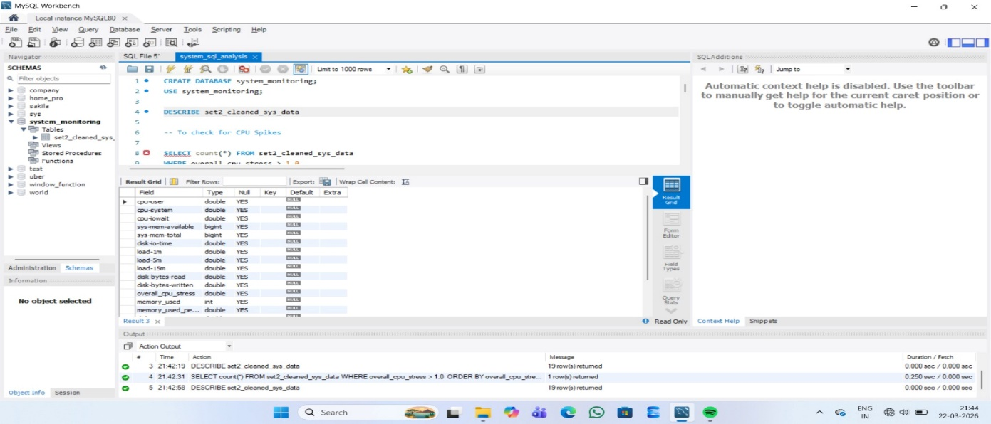

Exploratory Data Analysis
Exploratory Data Analysis (EDA) represents a critical and foundational phase in the data analysis lifecycle, as it enables a comprehensive understanding of the dataset before applying advanced analytical or modeling techniques. In the context of this project, EDA is performed to systematically examine system performance metrics and uncover meaningful patterns, trends, anomalies, and relationships that influence overall system behavior. By thoroughly exploring the dataset, it becomes possible to gain valuable insights into how system resources are utilized under different operational conditions, thereby supporting informed decision-making and effective performance optimization.
The process begins with the generation of statistical summaries for key performance indicators such as CPU usage, memory consumption, disk input/output operations, and system latency. Descriptive statistics, including mean, median, standard deviation, minimum, and maximum values, are calculated to understand the central tendency and variability of each metric. These statistical measures provide a quantitative overview of system performance, helping to establish a baseline for normal behavior. For instance, a consistently high average CPU usage may indicate sustained workload pressure, while a high standard deviation may suggest significant fluctuations that require further investigation. Such insights are essential for distinguishing between expected variations and potential performance issues.
Given the time-series nature of the dataset, time-based analysis plays a pivotal role in EDA. By examining system metrics across different time intervals—such as hourly, daily, and weekly patterns—it becomes possible to identify recurring trends and usage cycles. For example, the analysis may reveal that CPU usage peaks during standard business hours due to increased user activity, while it declines during late-night hours when system demand is minimal. Similarly, memory usage patterns can indicate whether the system maintains stability over time or experiences periodic spikes. These temporal insights are particularly valuable for capacity planning, as they enable organizations to allocate resources more effectively and schedule intensive tasks during off-peak periods.
Anomaly detection is another crucial component of exploratory analysis, as it focuses on identifying unusual or unexpected patterns in the data. Sudden spikes in CPU usage, abrupt drops in available memory, or irregular latency values may indicate underlying issues such as system faults, inefficient processes, or external disruptions. By carefully analyzing these anomalies, it becomes possible to determine their root causes and assess their impact on overall system performance. Early detection of such irregularities allows organizations to take proactive measures, reducing the risk of system failures and ensuring continuous operation.
In addition to individual metric analysis, correlation analysis is conducted to explore relationships between different system parameters. Understanding how metrics interact with one another provides deeper insights into system behavior. For instance, a strong positive correlation between CPU usage and latency suggests that increased processing load leads to slower response times, highlighting the need for load balancing or resource optimization. Similarly, a relationship between memory consumption and disk activity may indicate that insufficient memory is causing increased reliance on disk storage. These relationships are instrumental in identifying the root causes of performance bottlenecks and developing targeted solutions.
Visualization techniques significantly enhance the effectiveness of EDA by presenting complex data in a clear and intuitive manner. Graphical representations such as line charts, histograms, box plots, and scatter plots are used to illustrate trends, distributions, and relationships among variables. Line charts help visualize changes in performance metrics over time, while histograms provide insights into data distribution. Scatter plots reveal correlations between variables, and box plots highlight the presence of outliers. These visual tools not only simplify data interpretation but also enable quicker identification of patterns that may not be immediately apparent in raw data.
Furthermore, EDA supports hypothesis generation and validation, allowing analysts to test assumptions about system behavior. For example, if it is hypothesized that high CPU usage leads to increased latency, EDA techniques can be used to verify this relationship through correlation and visualization. This iterative process of exploration and validation strengthens the reliability of the analysis and ensures that conclusions are based on empirical evidence.
Overall, Exploratory Data Analysis serves as a vital step in transforming raw system performance data into actionable insights. It provides a detailed understanding of system behavior, highlights areas of concern, and lays the groundwork for further analysis and dashboard development. By leveraging statistical methods, time-based analysis, anomaly detection, and visualization techniques, EDA enables a comprehensive evaluation of system performance, ultimately contributing to improved efficiency, reliability, and decision-making in IT operations.

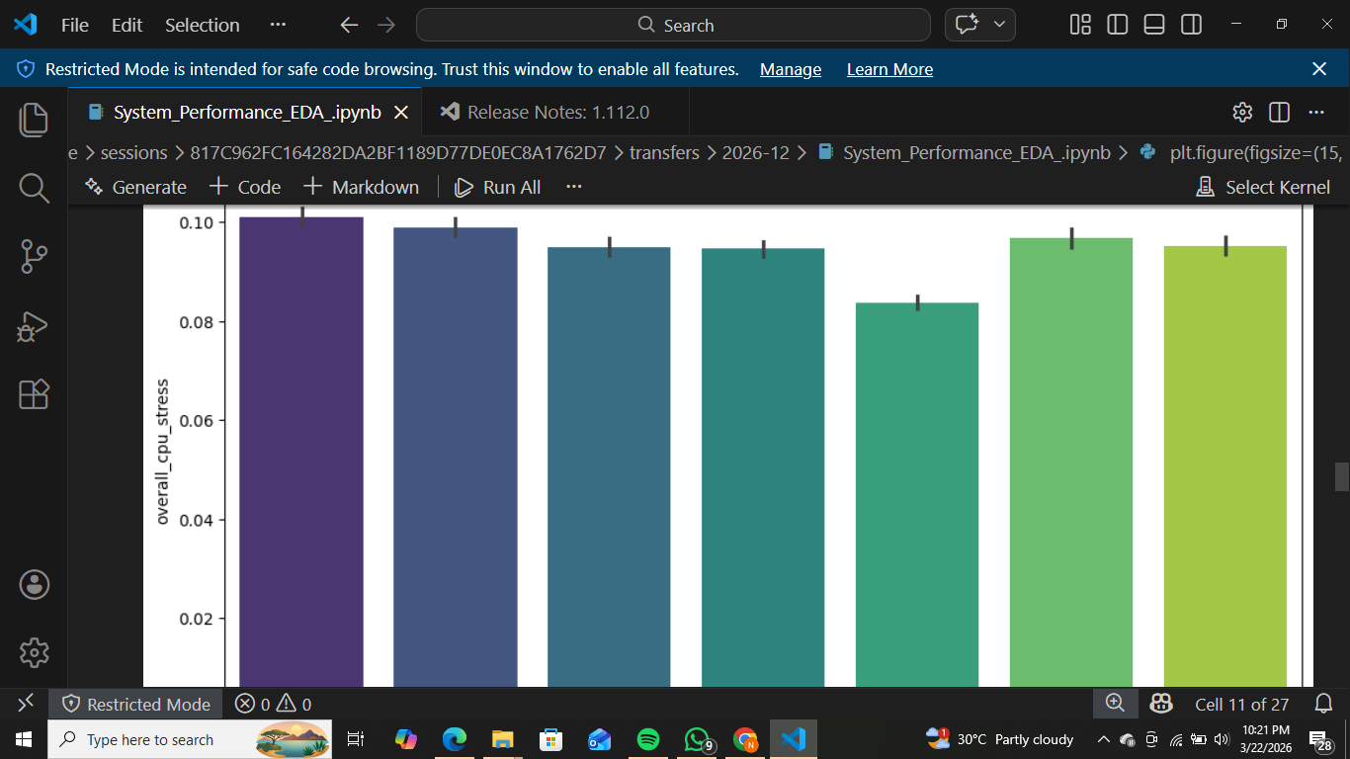

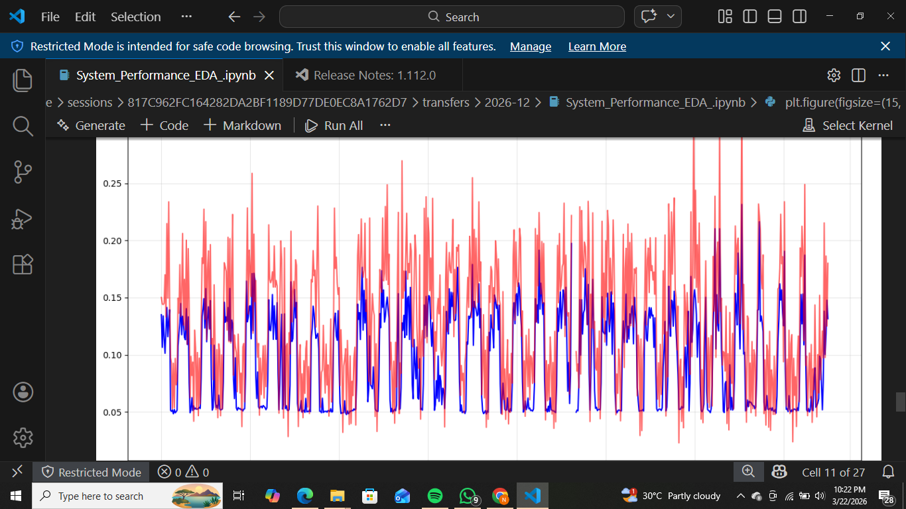

Tools Used
The successful implementation of this project relies on the integration of multiple tools, each serving a specific purpose in the data analysis and visualization process. These tools include Excel, SQL, Python, and Power BI, which collectively provide a comprehensive framework for handling data from initial exploration to final presentation.

Excel
Microsoft Excel serves as the foundational tool in the initial stages of this project, providing a simple yet powerful environment for data exploration, validation, and preprocessing. Due to its intuitive interface and widespread usage, Excel is often the first step in understanding raw datasets before moving to more advanced analytical tools. In this project, Excel plays a critical role in enabling a quick overview of the system performance data, helping to identify inconsistencies, missing values, and general data structure.
One of the most significant advantages of Excel is its ability to handle moderately large datasets while offering a wide range of built-in analytical features. The dataset used in this project, which includes system metrics such as CPU usage, memory consumption, and latency, is initially examined using Excel to verify its structure and integrity. This step ensures that the data is complete, properly formatted, and ready for further processing. Excel’s sorting and filtering capabilities allow users to isolate specific subsets of data, making it easier to focus on particular time periods or performance metrics.
Pivot tables are extensively utilized in this project to summarize and analyze large volumes of data efficiently. They enable the aggregation of data based on different dimensions, such as time intervals or metric categories, providing a clearer understanding of trends and patterns. For instance, pivot tables can be used to calculate average CPU usage per day or identify peak memory consumption periods. This functionality significantly reduces the complexity of manual calculations and enhances the efficiency of data analysis.
Conditional formatting is another powerful feature of Excel that is used to highlight anomalies and outliers in the dataset. By applying color scales or data bars, it becomes easier to visually identify unusual values, such as spikes in CPU usage or sudden drops in available memory. This visual representation helps in quickly detecting potential issues that require further investigation.
In addition to analysis, Excel is also used for basic data cleaning operations. Tasks such as removing duplicate entries, correcting formatting errors, and handling missing values are performed to ensure data consistency. These preprocessing steps are essential for maintaining data quality and preventing inaccuracies in subsequent analysis.
Despite the availability of more advanced tools, Excel remains an indispensable part of the data analysis workflow due to its accessibility, ease of use, and versatility. It provides a solid foundation for understanding the dataset and prepares it for more complex processing in tools like SQL, Python, and Power BI. Overall, Excel plays a crucial role in bridging the gap between raw data and advanced analytics, ensuring that the project begins with a strong and reliable data foundation.

SQL
Structured Query Language (SQL) is a fundamental tool used in this project for managing, querying, and transforming structured data. As the dataset grows in size and complexity, manual data handling becomes inefficient, making SQL an essential component for efficient data processing. SQL enables users to interact with relational databases, perform complex queries, and extract meaningful insights from large datasets with high accuracy and speed.
In this project, SQL is primarily used to retrieve and manipulate system performance data stored in structured formats. One of the key strengths of SQL is its ability to filter data based on specific conditions. For example, queries can be written to extract records where CPU usage exceeds a certain threshold, helping to identify periods of high system load. Similarly, SQL can be used to calculate aggregate values such as average memory usage, maximum latency, and total disk activity over a given time period.
Another important feature of SQL is its ability to perform grouping and aggregation operations. By using functions such as GROUP BY, SUM, AVG, and COUNT, it is possible to summarize large datasets into meaningful insights. For instance, grouping data by date or hour allows for the analysis of daily or hourly trends in system performance. This helps in identifying patterns such as peak usage times and recurring performance issues.
SQL also supports joining multiple datasets, which is particularly useful when dealing with data from different sources. By combining data tables, it becomes possible to create a more comprehensive view of system performance. This capability enhances the depth of analysis and enables the identification of relationships between different metrics.
Data integrity and consistency are critical aspects of any data analysis project, and SQL plays a key role in ensuring these qualities. By enforcing constraints and validation rules, SQL helps maintain the accuracy and reliability of the dataset. This is especially important when dealing with time-series data, where even small inconsistencies can lead to incorrect conclusions.
Furthermore, SQL improves efficiency by automating repetitive tasks. Instead of manually processing data, users can write queries that perform complex operations in a matter of seconds. This not only saves time but also reduces the likelihood of human error.
Overall, SQL serves as a powerful tool for data management and analysis in this project. Its ability to handle large datasets, perform complex operations, and ensure data integrity makes it an indispensable part of the system performance monitoring workflow.

Python
Python plays a central and highly significant role in this project, serving as the primary tool for data cleaning, analysis, and visualization. Its popularity in the field of data science is largely due to its simplicity, flexibility, and the availability of a vast ecosystem of libraries that support various aspects of data processing and analysis. In this project, Python is used to transform raw data into meaningful insights through a series of well-defined steps.
One of the key strengths of Python lies in its ability to handle large datasets efficiently. The pandas library is extensively used for data manipulation and preprocessing. It provides powerful data structures such as DataFrames, which allow for easy handling of structured data. Using pandas, tasks such as filtering data, handling missing values, converting data types, and creating new features can be performed efficiently. For example, timestamps can be converted into datetime format, and additional features such as hour and day can be extracted to facilitate time-based analysis.
Python also supports advanced data analysis techniques that go beyond basic statistical calculations. Using libraries such as NumPy and SciPy, it is possible to perform numerical computations and statistical analysis. These capabilities enable a deeper understanding of data patterns and relationships. For instance, correlation analysis can be performed to examine the relationship between CPU usage and latency, providing valuable insights into system performance.
Visualization is another area where Python excels. Libraries such as matplotlib and seaborn are used to create a wide range of charts and graphs, including line plots, histograms, and scatter plots. These visualizations help in understanding trends, distributions, and relationships within the data. Unlike basic tools, Python allows for customization of visualizations, making it possible to present data in a clear and informative manner.
In addition to analysis and visualization, Python is also used for anomaly detection and predictive analysis. By identifying unusual patterns in the data, such as sudden spikes in CPU usage or latency, it becomes possible to detect potential system issues early. This proactive approach helps in preventing system failures and improving overall performance.
Another advantage of Python is its ability to integrate with other tools and technologies. It can be used in conjunction with SQL databases for data retrieval and with Power BI for visualization. This interoperability makes Python a versatile tool that fits seamlessly into the overall workflow of the project.
Overall, Python significantly enhances the depth and quality of analysis in this project. Its powerful libraries, flexibility, and ease of use make it an essential tool for extracting meaningful insights from complex datasets and supporting data-driven decision-making.

Power BI
Power BI serves as the final and most crucial component of this project, providing a platform for creating an interactive and visually engaging system performance monitoring dashboard. As a leading business intelligence tool, Power BI enables the transformation of processed data into meaningful visual representations that can be easily understood by users at all levels, including both technical and non-technical stakeholders.
One of the key features of Power BI is its ability to connect to multiple data sources, including Excel files, SQL databases, and Python outputs. This integration capability allows for seamless data flow from different stages of the project into a unified dashboard. Once the data is imported, Power BI provides powerful data transformation tools that enable further cleaning and structuring of the dataset.
The dashboard created in this project includes a variety of visual elements designed to represent different system performance metrics. Line charts are used to display trends in CPU usage over time, while bar charts provide comparisons of memory usage across different periods. Additional visual elements such as cards and gauges are used to highlight key performance indicators, providing a quick overview of system health.
Interactivity is one of the most important aspects of Power BI dashboards. Users can apply filters to view data for specific time ranges or metrics, allowing for customized analysis. Drill-down features enable users to explore data at different levels of detail, from high-level summaries to granular insights. This interactive functionality enhances user engagement and makes the dashboard a powerful analytical tool.
Another significant advantage of Power BI is its ability to provide real-time or near real-time updates. This ensures that users always have access to the latest system performance data, enabling timely decision-making. In dynamic environments where system conditions can change rapidly, this feature is particularly valuable.
Power BI also supports storytelling through data by combining multiple visual elements into a cohesive narrative. The dashboard is designed in a way that guides users through the data, highlighting key insights and trends. This approach not only improves understanding but also helps in communicating findings effectively.
Overall, Power BI plays a vital role in this project by converting analytical results into actionable insights. Its powerful visualization capabilities, interactivity, and real-time updates make it an ideal tool for system performance monitoring. The dashboard serves as a comprehensive solution that enables organizations to monitor, analyze, and optimize system performance effectively.

Visualizations & Dashboard Explanation
Visualizations play a central role in this project as they convert complex and high-volume system performance data into an easily interpretable format. Raw data, when presented in tabular form, often becomes difficult to analyze, especially when dealing with continuous time-series data such as CPU usage, memory consumption, and latency. Therefore, the use of effective visualization techniques is essential to simplify the interpretation process and enable quick decision-making. In this project, multiple types of visualizations are used strategically to represent different aspects of system performance, ensuring that each metric is communicated clearly and effectively.
Line charts are extensively used to illustrate trends in CPU utilization over time. These charts provide a continuous view of how system load varies across different hours and days, making it easier to identify peak usage periods and recurring patterns. By observing these trends, system administrators can understand workload behavior and plan resource allocation accordingly. Histograms are used to represent the distribution of memory usage, allowing for the identification of frequently occurring memory levels as well as unusual spikes. This helps in understanding whether the system operates within a stable range or experiences frequent fluctuations.
Scatter plots are utilized to examine relationships between different variables, such as CPU usage and latency or memory consumption and system load. These visualizations are particularly useful in identifying correlations and dependencies among metrics. For instance, a positive correlation between CPU usage and latency may indicate that higher processing demand leads to slower system responses. Such insights are crucial for diagnosing performance issues and improving system efficiency.
The dashboard itself is designed with a strong emphasis on user experience and accessibility. It follows a structured layout where each section is dedicated to a specific performance metric, ensuring clarity and ease of navigation. Key metrics are displayed prominently using summary cards, while detailed trends are shown through charts and graphs. The use of consistent color schemes and labels enhances readability and helps users quickly interpret the data.
Interactive features are a major highlight of the dashboard. Users can apply filters to view data for specific time periods, such as particular days or hours. Drill-down functionality allows users to explore data at a more granular level, enabling deeper analysis of specific events or anomalies. These interactive capabilities transform the dashboard from a static reporting tool into a dynamic analytical platform.
Furthermore, the dashboard supports real-time or near real-time data updates, ensuring that users have access to the most current information. This is particularly important in environments where system performance can change rapidly. By providing timely insights, the dashboard enables proactive monitoring and faster response to potential issues.
Overall, the integration of diverse visualization techniques and interactive features results in a comprehensive and effective monitoring solution. The dashboard not only presents data but also tells a story about system performance, helping users understand trends, identify problems, and make informed decisions.

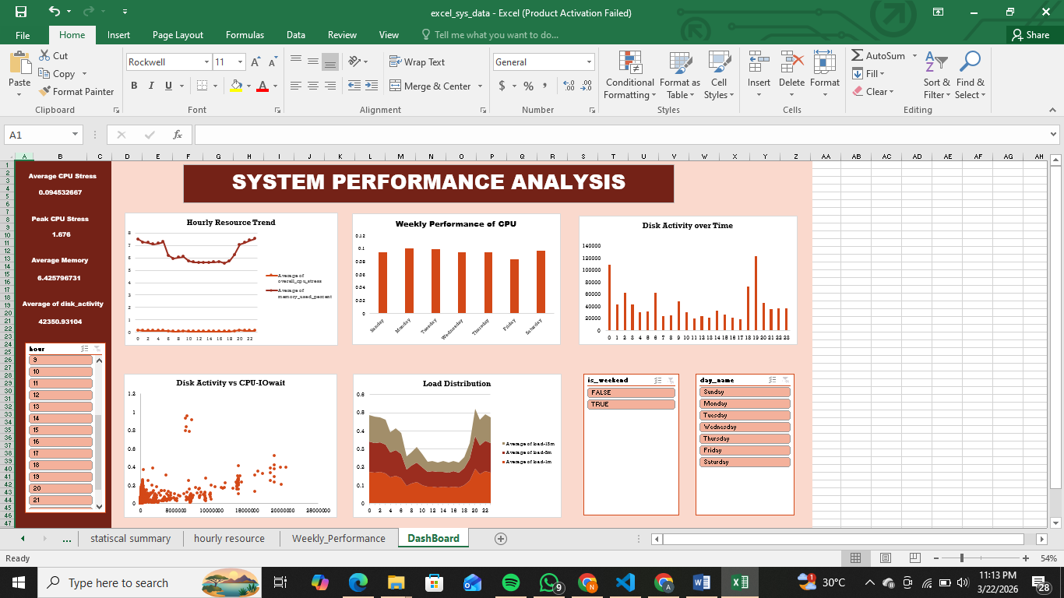

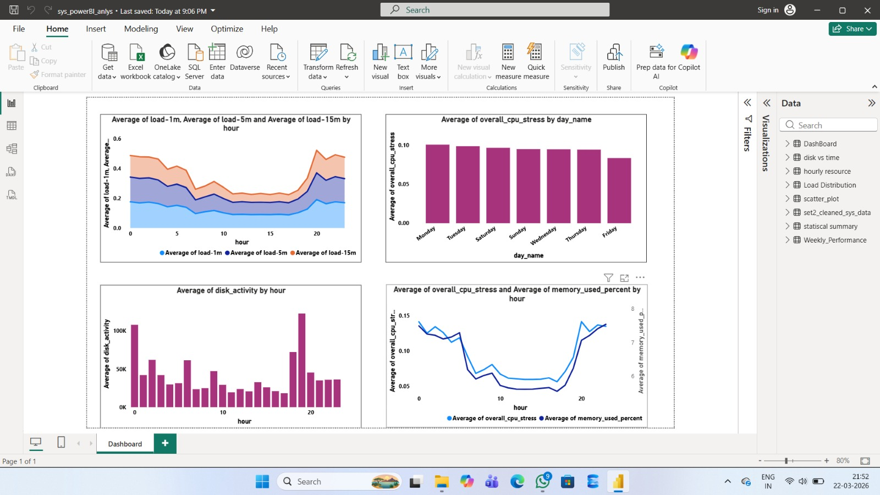

Key Insights
The detailed analysis of system performance data has led to the identification of several important insights that provide a deeper understanding of system behavior. One of the most significant findings is the identification of peak CPU usage periods, which occur at specific times of the day. These peak periods typically correspond to increased user activity or scheduled system processes, resulting in higher demand for processing resources. Understanding these patterns is essential for optimizing system performance, as it allows administrators to anticipate high workload periods and prepare accordingly.
Another important insight is related to memory utilization. The analysis reveals that memory usage remains relatively stable for most of the time, indicating efficient resource management. However, occasional spikes in memory consumption are observed during peak activity periods. These spikes may be caused by resource-intensive applications or processes that require additional memory. Identifying such patterns helps in pinpointing areas where optimization is needed, such as improving application efficiency or increasing memory capacity.
Latency analysis provides further valuable insights into system performance. The data indicates that latency tends to increase during periods of high CPU usage, suggesting a direct relationship between system load and response time. This correlation highlights the importance of balancing system resources to ensure smooth operation. High latency can negatively impact user experience, particularly in applications that require real-time interaction. Therefore, understanding the factors that contribute to latency is crucial for improving system responsiveness.
The analysis also uncovers patterns related to disk activity and system load. Increased disk I/O operations are often observed during periods of high system usage, indicating that storage performance plays a significant role in overall system efficiency. Load averages further support these observations by showing higher values during peak periods, reflecting increased demand for processing resources.
In addition to these findings, anomaly detection reveals instances of sudden spikes or drops in performance metrics. These anomalies may indicate unusual system behavior, such as unexpected workloads or potential system issues. Identifying and analyzing these events helps in understanding their causes and implementing preventive measures.
Overall, the insights gained from this analysis provide a comprehensive understanding of system performance. They highlight key areas for improvement and serve as a foundation for developing effective optimization strategies. By leveraging these insights, organizations can enhance system efficiency, reduce downtime, and improve user satisfaction.

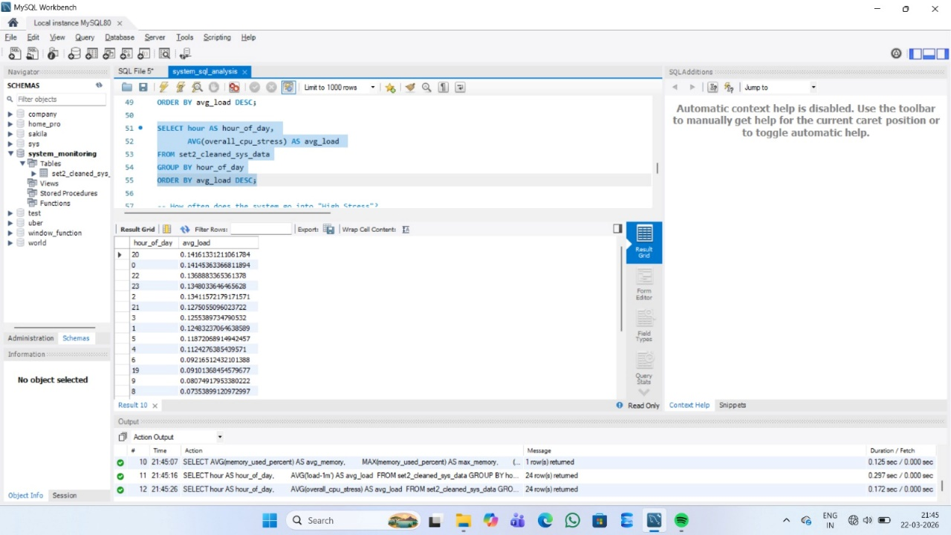

Business Recommendations
Based on the insights derived from the analysis, several strategic recommendations can be made to improve system performance and ensure efficient resource utilization. One of the primary recommendations is to schedule resource-intensive tasks during periods of low system activity. By shifting heavy workloads to off-peak hours, organizations can reduce system strain during high-demand periods and maintain consistent performance levels.
Another important recommendation is to implement continuous monitoring of high usage periods. By closely observing system behavior during peak times, administrators can identify potential bottlenecks and take corrective actions before they impact system performance. This proactive approach helps in minimizing disruptions and ensuring smooth operations.
The implementation of automated alert systems is also highly recommended. These systems can be configured to trigger notifications when specific thresholds are exceeded, such as high CPU usage or low available memory. Early detection of potential issues allows for timely intervention, reducing the risk of system failures and downtime.
Scalability is another key aspect that organizations should consider. As workloads increase, it is important to ensure that the system infrastructure can handle the additional demand. Dynamic scaling, particularly in cloud environments, allows resources to be adjusted based on real-time requirements. This ensures optimal performance while avoiding unnecessary costs.
Predictive monitoring techniques can further enhance system performance management. By analyzing historical data and identifying patterns, it is possible to predict future performance trends and potential issues. This enables organizations to take preventive measures and improve system reliability.
Additionally, optimizing application performance can contribute significantly to overall system efficiency. This includes improving code efficiency, reducing unnecessary processes, and ensuring proper resource allocation. Regular system audits and performance reviews can help identify areas for improvement.
In conclusion, the implementation of these recommendations can lead to significant improvements in system performance. By adopting a proactive and data-driven approach, organizations can enhance efficiency, reduce downtime, and provide a better user experience.

Conclusion
The System Performance Monitoring Dashboard developed in this project represents a comprehensive solution for analyzing, visualizing, and optimizing system performance in modern IT environments. As organizations continue to rely on digital systems for their operations, the need for efficient monitoring tools becomes increasingly important. This project successfully demonstrates how data analysis and visualization techniques can be integrated to create a powerful monitoring solution that supports informed decision-making.
Throughout the project, various stages of data processing have been implemented, including data collection, cleaning, analysis, and visualization. Each stage plays a crucial role in ensuring the accuracy and reliability of the final output. The use of tools such as Excel, SQL, Python, and Power BI highlights the importance of combining multiple technologies to achieve comprehensive results. These tools not only facilitate efficient data handling but also enhance the overall quality of analysis.
The insights gained from the project provide valuable information about system behavior, including peak usage periods, resource utilization patterns, and performance bottlenecks. These insights are essential for optimizing system performance and ensuring smooth operations. By identifying potential issues early, organizations can take proactive measures to prevent system failures and minimize downtime.
Furthermore, the interactive dashboard serves as a user-friendly platform that simplifies complex data and makes it accessible to both technical and non-technical users. Its ability to provide real-time insights and support detailed analysis makes it a valuable tool for system administrators and decision-makers.
In a broader context, this project highlights the significance of data-driven approaches in IT management. As systems become more complex, traditional monitoring methods are no longer sufficient. Advanced tools and techniques are required to handle large volumes of data and extract meaningful insights. This project serves as an example of how such approaches can be effectively implemented.
In conclusion, the System Performance Monitoring Dashboard not only addresses the challenges of system performance management but also provides a scalable and adaptable solution that can be applied across various industries. It emphasizes the importance of proactive monitoring, efficient resource management, and continuous improvement, making it a valuable contribution to modern IT practices.

References
The development of the System Performance Monitoring Dashboard is supported by a wide range of academic literature, technical documentation, and industry resources. These references provide foundational knowledge in areas such as system monitoring, database management, data analysis, and visualization techniques. The combination of research papers, textbooks, and official documentation ensures both theoretical depth and practical relevance in the implementation of this project.

System Monitoring & Dashboards
Barham, P., Dragovic, B., Fraser, K., Hand, S., Harris, T., Ho, A., Neugebauer, R., Pratt, I., & Warfield, A. (2003). Xen and the Art of Virtualization. ACM Symposium on Operating Systems Principles.
This paper provides fundamental insights into virtualization technologies, which are essential for understanding modern system monitoring environments.
Grafana Labs. (2025). Grafana Documentation: Building Dashboards for System Monitoring. Retrieved from https://grafana.com/docs
This documentation explains how dashboards can be used for real-time monitoring and visualization of system metrics.
Prometheus Authors. (2025). Prometheus Monitoring System Documentation. Retrieved from https://prometheus.io/docs
Prometheus provides an open-source framework for monitoring and alerting, widely used in cloud-native environments.
Turnbull, J. (2018). The Prometheus Monitoring System. Turnbull Press.
This book offers practical insights into implementing monitoring solutions using Prometheus.

SQL & Database Analysis
Oracle Corporation. (2025). MySQL 8.0 Reference Manual. Retrieved from https://dev.mysql.com/doc
This official documentation provides comprehensive guidance on SQL queries and database management.
Elmasri, R., & Navathe, S. (2016). Fundamentals of Database Systems (7th ed.). Pearson.
A widely used textbook that explains database concepts, normalization, and query processing.
Silberschatz, A., Korth, H., & Sudarshan, S. (2019). Database System Concepts (7th ed.). McGraw-Hill.
This book provides a deeper understanding of relational databases and SQL operations.
Date, C. J. (2015). An Introduction to Database Systems. Pearson.
A foundational resource for understanding database design and data integrity.

Python & Data Analysis
McKinney, W. (2017). Python for Data Analysis: Data Wrangling with Pandas, NumPy, and IPython. O’Reilly Media.
This book is essential for understanding data manipulation and analysis using Python.
Hunter, J. D. (2007). Matplotlib: A 2D Graphics Environment. Computing in Science & Engineering, 9(3), 90–95.
This paper explains the fundamentals of data visualization using matplotlib.
Waskom, M. L. (2021). Seaborn: Statistical Data Visualization. Journal of Open Source Software, 6(60), 3021.
Seaborn enhances visualization capabilities and supports statistical analysis.
VanderPlas, J. (2016). Python Data Science Handbook. O’Reilly Media.
Provides practical examples of data analysis and visualization using Python libraries.
NumPy Developers. (2025). NumPy Documentation. Retrieved from https://numpy.org/doc
Official documentation for numerical computations in Python.

Power BI & Data Visualization
Microsoft Corporation. (2025). Power BI Documentation: Interactive Dashboards and Reports. Retrieved from https://learn.microsoft.com/power-bi
Provides detailed guidance on building dashboards and visual reports.
Few, S. (2009). Now You See It: Simple Visualization Techniques for Quantitative Analysis. Analytics Press.
Focuses on effective data visualization techniques for decision-making.
Knaflic, C. N. (2015). Storytelling with Data. Wiley.
Explains how to communicate insights effectively through visualizations.
Tufte, E. R. (2001). The Visual Display of Quantitative Information. Graphics Press.
A classic reference on designing clear and effective visualizations.

System Performance & Resource Management
Hennessy, J. L., & Patterson, D. A. (2017). Computer Architecture: A Quantitative Approach (6th ed.). Morgan Kaufmann.
Provides a detailed understanding of system performance metrics and architecture.
Jain, R. (1991). The Art of Computer Systems Performance Analysis. Wiley.
A foundational book on performance evaluation techniques.
IEEE Computer Society. (2024). Resource Monitoring in Distributed Systems. IEEE Transactions on Computers.
Discusses modern approaches to monitoring distributed systems.
Menascé, D. A., & Almeida, V. A. (2002). Capacity Planning for Web Services. Prentice Hall.
Focuses on workload management and system scalability.

Cloud Computing & Monitoring Systems
Amazon Web Services. (2025). AWS CloudWatch Documentation. Retrieved from https://aws.amazon.com/cloudwatch
Provides insights into cloud-based monitoring solutions.
Google Cloud. (2025). Cloud Monitoring Documentation. Retrieved from https://cloud.google.com/monitoring
Explains monitoring techniques in cloud environments.
NIST. (2020). Cloud Computing Standards and Guidelines. National Institute of Standards and Technology.
Defines best practices for cloud-based systems.

General Data Analytics & IT Systems
Provost, F., & Fawcett, T. (2013). Data Science for Business. O’Reilly Media.
Explains the importance of data-driven decision-making.
Kleppmann, M. (2017). Designing Data-Intensive Applications. O’Reilly Media.
Covers system design and data processing in modern applications.
Gartner Research. (2024). Trends in Business Intelligence and Analytics.
Provides industry insights into analytics and dashboard usage.
ACM Digital Library. (2025). Research Articles on System Monitoring and Optimization.
A collection of academic papers related to system performance.

